<https://postgrespro.ru/docs/postgresql/15/functions-conditional>

Задание 1

<https://metabase.sky.pro/question/59723>

with first_payments as -- дата первой успешной (со статусом success) транзакции

(

select user_id, min(transaction_datetime::date) as first_payment_date

from skyeng_db.payments

where status_name = 'success'

group by user_id

order by first_payment_date

),

all_dates as -- все дни 2016 года

(

select distinct date_trunc('day', class_start_datetime) as dt

from skyeng_db.classes

where class_start_datetime between '2016-01-01' and '2016-12-31'

order by dt

),

all_dates_by_user as

(

select user_id, dt -- все даты жизни студента после того, как произошла его первая транзакция

from first_payments as fp

join all_dates as ad on fp.first_payment_date <= ad.dt

order by user_id, dt

),

classes_by_dates as

(

select user_id, class_start_datetime::date as class_date, count(id_class) *(-1) as classes

from skyeng_db.classes

where class_status in ('success', 'failed_by_student') and class_type != 'trial'

group by user_id, class_date

order by user_id

),

payments_by_dates as -- список успешных транзакций

(

select user_id, transaction_datetime::date as payment_date, sum(classes) as transaction_balance_change

from skyeng_db.payments

where id_transaction is not null and status_name = 'success'

group by user_id, payment_date

order by user_id, payment_date

),

payments_by_dates_cumsum as

(

select ad.user_id, dt, transaction_balance_change,

sum(transaction_balance_change) over (partition by ad.user_id order by dt) as transaction_balance_change_cs

from all_dates_by_user as ad

left join payments_by_dates as pd on ad.user_id= pd.user_id and ad.dt=pd.payment_date

)

select *

from payments_by_dates_cumsum

Задание 2

<https://metabase.sky.pro/question/59850>

with first_payments as -- дата первой успешной (со статусом success) транзакции

(

select user_id, min(transaction_datetime::date) as first_payment_date

from skyeng_db.payments

where status_name = 'success'

group by user_id

order by first_payment_date

),

all_dates as -- все дни 2016 года

(

select distinct date_trunc('day', class_start_datetime) as dt

from skyeng_db.classes

where class_start_datetime between '2016-01-01' and '2016-12-31'

order by dt

),

all_dates_by_user as

(

select user_id, dt -- все даты жизни студента после того, как произошла его первая транзакция

from first_payments as fp

join all_dates as ad on fp.first_payment_date <= ad.dt

order by user_id, dt

),

classes_by_dates as

(

select user_id, class_start_datetime::date as class_date, count(id_class) *(-1) as classes

from SKYENG_DB.classes

where class_status in ('success', 'failed_by_student') and class_type != 'trial'

group by user_id, class_date

order by user_id

),

payments_by_dates as -- список успешных транзакций

(

select user_id, transaction_datetime::date as payment_date, sum(classes) as transaction_balance_change

from skyeng_db.payments

where id_transaction is not null and status_name = 'success'

group by user_id, payment_date

order by user_id, payment_date

),

payments_by_dates_cumsum as

(

select ad.user_id, dt, transaction_balance_change,

sum(transaction_balance_change) over (partition by ad.user_id order by dt) as transaction_balance_change_cs

from all_dates_by_user as ad

left join payments_by_dates as pd on ad.user_id= pd.user_id and ad.dt=pd.payment_date

),

classes_by_dates_dates_cumsum as

(

select ad.user_id, dt, classes,

sum(classes) over (partition by ad.user_id order by dt) as classes_cs

from all_dates_by_user as ad

left join classes_by_dates as cd on ad.user_id= cd.user_id and ad.dt=cd.class_date

)

select *

from classes_by_dates_dates_cumsum

Задание 3

<https://metabase.sky.pro/question/59856>

with first_payments as -- дата первой успешной (со статусом success) транзакции

(

select user_id, min(transaction_datetime::date) as first_payment_date

from skyeng_db.payments

where status_name = 'success'

group by user_id

order by first_payment_date

),

all_dates as -- все дни 2016 года

(

select distinct date_trunc('day', class_start_datetime) as dt

from skyeng_db.classes

where class_start_datetime between '2016-01-01' and '2016-12-31'

order by dt

),

all_dates_by_user as

(

select user_id, dt -- все даты жизни студента после того, как произошла его первая транзакция

from first_payments as fp

join all_dates as ad on fp.first_payment_date <= ad.dt

order by user_id, dt

),

classes_by_dates as

(

select user_id, class_start_datetime::date as class_date, count(id_class) *(-1) as classes

from SKYENG_DB.classes

where class_status in ('success', 'failed_by_student') and class_type != 'trial'

group by user_id, class_date

order by user_id

),

payments_by_dates as -- список успешных транзакций

(

select user_id, transaction_datetime::date as payment_date, sum(classes) as transaction_balance_change

from skyeng_db.payments

where id_transaction is not null and status_name = 'success'

group by user_id, payment_date

order by user_id, payment_date

),

payments_by_dates_cumsum as

(

select ad.user_id, dt, transaction_balance_change,

sum(transaction_balance_change) over (partition by ad.user_id order by dt) as transaction_balance_change_cs

from all_dates_by_user as ad

left join payments_by_dates as pd on ad.user_id= pd.user_id and ad.dt=pd.payment_date

),

classes_by_dates_dates_cumsum as

(

select ad.user_id, dt, classes,

sum(classes) over (partition by ad.user_id order by dt) as classes_cs

from all_dates_by_user as ad

left join classes_by_dates as cd on ad.user_id= cd.user_id and ad.dt=cd.class_date

),

balances as

(

select pdc.user_id, pdc.dt, transaction_balance_change, transaction_balance_change_cs, cddc.classes,

classes_cs, (classes_cs + transaction_balance_change_cs) as balance

from payments_by_dates_cumsum as pdc

left join classes_by_dates_dates_cumsum as cddc on pdc.user_id=cddc.user_id and pdc.dt=cddc.dt

)

select *

from balances

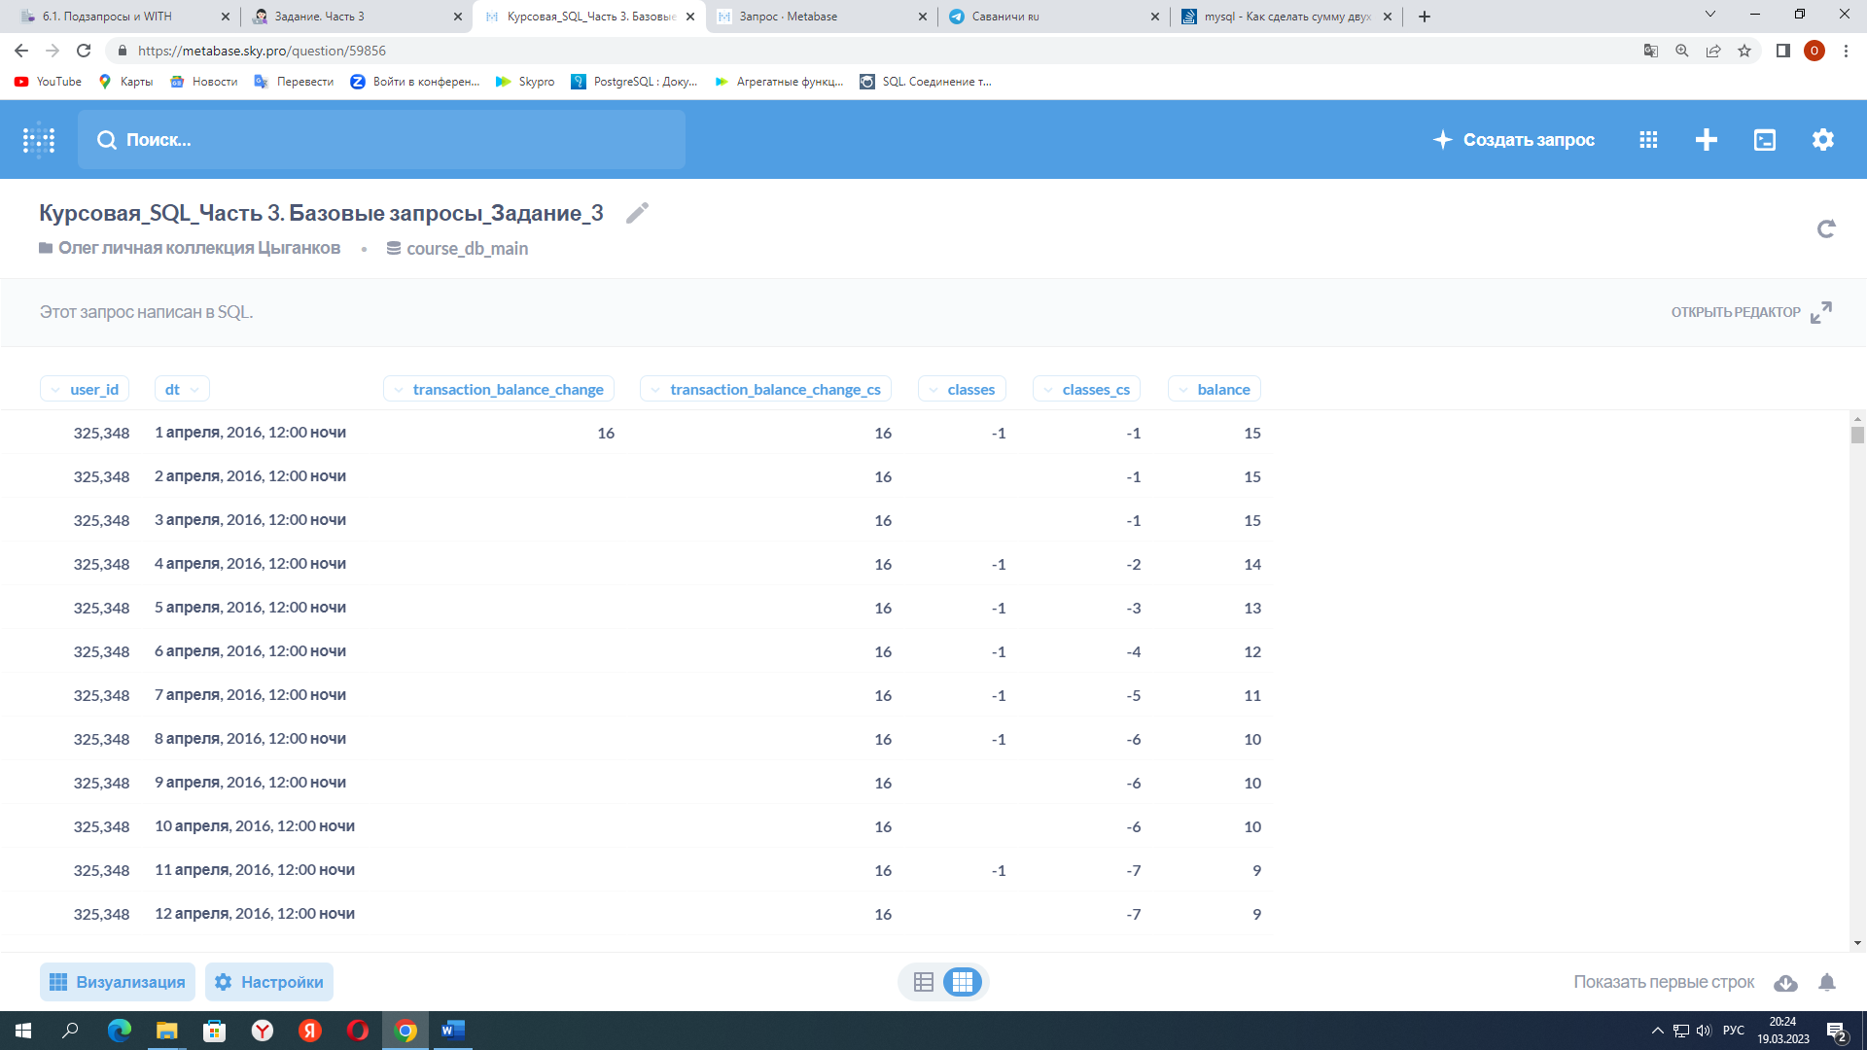

Задание 4

<https://metabase.sky.pro/question/59862>

with first_payments as -- дата первой успешной (со статусом success) транзакции

(

select user_id, min(transaction_datetime::date) as first_payment_date

from skyeng_db.payments

where status_name = 'success'

group by user_id

order by first_payment_date

),

all_dates as -- все дни 2016 года

(

select distinct date_trunc('day', class_start_datetime) as dt

from skyeng_db.classes

where class_start_datetime between '2016-01-01' and '2016-12-31'

order by dt

),

all_dates_by_user as

(

select user_id, dt -- все даты жизни студента после того, как произошла его первая транзакция

from first_payments as fp

join all_dates as ad on fp.first_payment_date <= ad.dt

order by user_id, dt

),

classes_by_dates as

(

select user_id, class_start_datetime::date as class_date, count(id_class) *(-1) as classes

from SKYENG_DB.classes

where class_status in ('success', 'failed_by_student') and class_type != 'trial'

group by user_id, class_date

order by user_id

),

payments_by_dates as -- список успешных транзакций

(

select user_id, transaction_datetime::date as payment_date, sum(classes) as transaction_balance_change

from skyeng_db.payments

where id_transaction is not null and status_name = 'success'

group by user_id, payment_date

order by user_id, payment_date

),

payments_by_dates_cumsum as

(

select ad.user_id, dt, transaction_balance_change,

sum(transaction_balance_change) over (partition by ad.user_id order by dt) as transaction_balance_change_cs

from all_dates_by_user as ad

left join payments_by_dates as pd on ad.user_id= pd.user_id and ad.dt=pd.payment_date

),

classes_by_dates_dates_cumsum as

(

select ad.user_id, dt, classes,

sum(classes) over (partition by ad.user_id order by dt) as classes_cs

from all_dates_by_user as ad

left join classes_by_dates as cd on ad.user_id= cd.user_id and ad.dt=cd.class_date

),

balances as

(

select pdc.user_id, pdc.dt, transaction_balance_change, transaction_balance_change_cs, cddc.classes,

classes_cs, (classes_cs + transaction_balance_change_cs) as balance

from payments_by_dates_cumsum as pdc

left join classes_by_dates_dates_cumsum as cddc on pdc.user_id=cddc.user_id and pdc.dt=cddc.dt

)

select *

from balances

order by user_id, dt

limit 1000

-- Анализируя изменения балансов студентов, видим, что некоторым студентам после исчерпания предоплаченных сумм, несколько уроков предоставляются в долг до следующей предоплаты:

-- user_id 1984910 с 07.07.2016 по 31.07.2016

-- user_id 3335256 с 09.11.2016 по 30.12.2016

-- user_id 6270209 с 16.08.2016 по 27.09.2016

-- Либо это ошибки в данных по оплатам студентов, либо исчерпание баланса никак не фиксируется и не приостанавливается доступ к урокам?

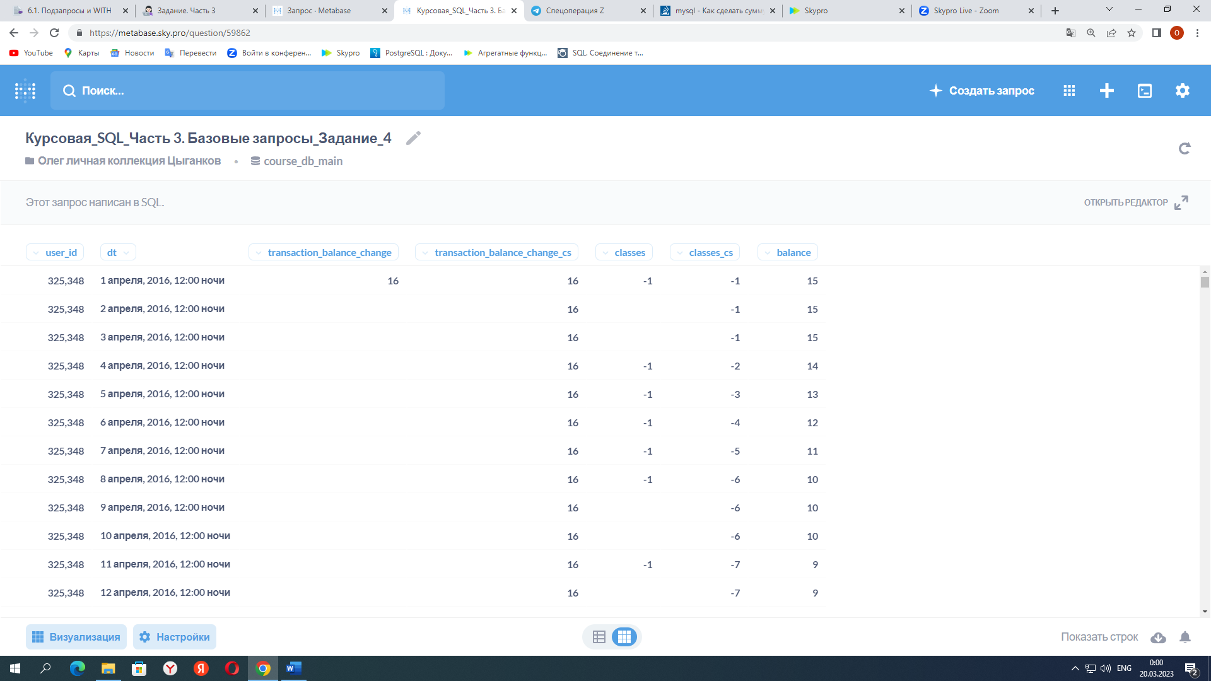

Задание 5

<https://metabase.sky.pro/question/59873>

with first_payments as -- дата первой успешной (со статусом success) транзакции

(

select user_id, min(transaction_datetime::date) as first_payment_date

from skyeng_db.payments

where status_name = 'success'

group by user_id

order by first_payment_date

),

all_dates as -- все дни 2016 года

(

select distinct date_trunc('day', class_start_datetime) as dt

from skyeng_db.classes

where class_start_datetime between '2016-01-01' and '2017-01-01'

order by dt

),

all_dates_by_user as

(

select user_id, dt -- все даты жизни студента после того, как произошла его первая транзакция

from first_payments as fp

join all_dates as ad on fp.first_payment_date <= ad.dt

order by user_id, dt

),

classes_by_dates as

(

select user_id, class_start_datetime::date as class_date, count(id_class) *(-1) as classes

from skyeng_db.classes

where class_status in ('success', 'failed_by_student') and class_type != 'trial'

group by user_id, class_date

order by user_id

),

payments_by_dates as -- список успешных транзакций

(

select user_id, transaction_datetime::date as payment_date, sum(classes) as transaction_balance_change

from skyeng_db.payments

where id_transaction is not null and status_name = 'success'

group by user_id, payment_date

order by user_id, payment_date

),

payments_by_dates_cumsum as

(

select ad.user_id, dt, transaction_balance_change,

sum(transaction_balance_change) over (partition by ad.user_id order by dt) as transaction_balance_change_cs

from all_dates_by_user as ad

left join payments_by_dates as pd on ad.user_id= pd.user_id and ad.dt=pd.payment_date

),

classes_by_dates_dates_cumsum as

(

select ad.user_id, dt, classes,

sum(classes) over (partition by ad.user_id order by dt) as classes_cs

from all_dates_by_user as ad

left join classes_by_dates as cd on ad.user_id= cd.user_id and ad.dt=cd.class_date

),

balances as

(

select pdc.user_id, pdc.dt, transaction_balance_change, transaction_balance_change_cs, cddc.classes,

classes_cs, (classes_cs + transaction_balance_change_cs) as balance

from payments_by_dates_cumsum as pdc

left join classes_by_dates_dates_cumsum as cddc on pdc.user_id=cddc.user_id and pdc.dt=cddc.dt

)

select dt,

sum(transaction_balance_change) as sum_transaction_balance_change,

sum(transaction_balance_change_cs) as sum_transaction_balance_change_cs,

sum(classes) as sum_classes,

sum(classes_cs) as sum_classes_cs,

sum(balance) as sum_balance

from balances

group by dt

order by dt

